Press Comments

“Cheryl is one artist who you will not soon forget. Her music borders on symphonic but rests in the realm of pop. With the voice of an angel, Cheryl has the gift of touching you with her lyric and melody on some amazing songs. She has written in three languages; English, Spanish and French and sounds like she was born to them. I have found in following her career that she is one of those songwriters that gets adopted wherever she performs. She has worked in venues, festivals and concert halls in the states and Canada; receives airplay worldwide and even sung at sporting events. She is a stage performer, radio artist and model. I would venture to say that Cheryl Nye is a renaissance woman of the first order and it is an honor to have her as a guest on the show”.
-Douglas Dickens: On Air Personality /Host/ DJ “MixPosure”. (USA)

“Here’s a Goddess if I ever saw one... I want to see this track in the next James Bond movie”.
-DJ Tanya Dower (SoulKettle) “The Night Of The Goddess”
Loop-Radio-UK

“This song (Eyes Of A Stranger) has James Bond written all over it. Get it to Eon Productions. It belongs in one of their movies.” (RE: “Eyes of A Stranger”)
-The ICEMAN
Host/DJ : “Best Country Radio”
“Top 40 New Country Artist Countdown Show”.

“Its one of the best songs ever written in the world for movie Soundtracks”
-Dan (2014)
DJ/Guest Host: Fame Music Radio (RE: “Eyes Of A Stranger”)

“....Nye takes on a whole new persona when performing....she transforms herself into a flamboyant, theatrical and visually voluptuous performer....her huge green eyes lighting up your heart.”
— Nancy Snipper, The Monitor, Montreal Canada

"About fashion Cheryl says: "It is an expression of our inner fire. I'm enchanted and captivated with dramatic styles of makeup and clothes and with the intensity of bold color. With fashion, we may dare to express our originality; albeit bordering on the realms of fantasy...
— The late Iona Monahan Fashion Segment on Local Celebrities "Beauty In Black", Montreal Gazette

“Should be a movie soundtrack if there is any justice in the world”. She’s got the pipes to sing the track”… “Cheryl Nye could easily be a Bond girl if she wanted to”…”Sultry, delicious, Cheryl Nye…great song, great presence, great track here….This wonderful tribute to the James Bond movies”. “Entrancing track”. “Enthralling”.

Alan Wayne
Owner/Host/Dj
Indie Star Radio Network
(California, USA)
Jan. 2018

#1 song… “Right where you should be”. “Her tracks are always a cut above all the rest”. Every time I hear Cheryl sing I get goose bumps!”.

Georg Hegelmann
Owner/Host /DJ
Fame Music Radio,
Johannesburg, South Africa/Los Angeles.
Dec.2018

Cheryl Nye: “Gleaming Gem of Montreal”. …“That’s your Cheryl Nye fix”

Ray Powers
Owner/DJ/Host “They Ray Powers Hour
New Visions Radio (New York, NY,USA)
Feb.1st,2018.

“Eyes of a Stranger” has James Bond theme written all over it. We like that!"
-Chris Duval,(Owner/Host/DJ) Splashradio. (U.K.) London.

“You listen out of curiosity, but from her first note her effervescence grabs you. I heard the angels singing and her name is Cheryl Nye. ”
-Bram Eisenthal (Local Seeker Magazine)

“Cheryl Wows 'Em in New York”
-The Suburban Montreal (Cover) Regarding opening for Country Superstar Aaron Tippin, New York)

“Cheryl Nye’s new Album “Eyes of a Stranger” is like Cupid's arrow striking ones heart to fulfill a prophecy of love, life, light, peace and serenity. The emotional experiences and instrumentation of sound are beyond words, they can be described as heavenly, haunting, melodic and very soothing. The beautiful repertoire of sounds offers a mix of very diverse instrumentals that hook you with their Celtic, and Spanish and orchestrated beats along with Cheryl's beautiful vocals. The lyrics powerful, beautiful, they take on a life of their own and to the listener they are personal as they can relate them to relationships they experience in life. Tune in and listen for more.”
-Tina Wilson
Global Entertainment Magazine

“....you rock Cheryl , your music is outstanding. Such well arranged and thoughtful compositions. Your vocals are beautiful and full of passion, and your instrumentals knock me out. Stunning, Awesome. ...like top drawer...Bryon ”
— Bryon Tosoff, Reverbnation Artist (USA)

“.......I guess you could describe my stage clothing as eccentric, but I think an entertainer should look a little different...”
— from interview with Bill Brownstein, The Montreal Gazette

“...there are a lot of negative things in the world and I like looking at the positive. Singer and songwriter Cheryl Nye is an avowed romantic, so it's no surprise that most of her songs are contemporary love ballads.”
— Charlie Fidelman, The Montreal Gazette

“this lady delivers her material in a dramatic, emotion-filled style, with a solid,soaring voice over a huge orchestral presentation.”
— Raymond J. Arsenault, The Journal Pioneer

“..one nice touch is that she is a class act...she's too good to keep under wraps.”
— Bram Eisenthal, The Suburban- Montreal, Canada

“Nye said her growing success in the last few years has taught her that if you have a desire to do something you can do it. Everyone has a chance to do what they want in life.”
— Anna Jolly, The Press Republication-Plattsburgh, New York US

Sweet, smooth and stylish. Did I forget anything? Well, Cheryl Nye, who is a multi-lingual vocalist and pianist from Montreal, performs with grace and style, with songs she has composed (music and lyrics) herself. She comes from a vocal and piano course curriculum in college and learned her lessons well, but her "craft work" that is the hallmark of any true songwriter is covered like a veneer by a flowing interpretive style. She is very active performing in Quebec but it would be no surprise to me if she crosses the border to share her vast talent and beauty with American audiences. As she climbs up the Pop mountain, rated #1 in the Montreal Pop polls, I would expect a smart promoter first would bring her to audiences in New York, Las Vegas, Los Angeles, London, Paris and Sydney to showcase her immense stage presence and silky, sultry voice!
-Deke Donovan’s
Power Performer’s Of Music

“Singer, Songwriter, and artist, her phenomenal talent is loved by all who are touched by her gifts”.
-The late Robert Morris
Owner / Robert Morris Music Group
Memphis, TN. USA

....”Eyes Of A Stranger” would make a great Bond song.
The Bond girls don’t match the beauty of Cheryl Nye”

-Helder Rock
DJ/Host: Rock N Stock
Mixposure Radio (U.K.) 2014

Steven F. Adams
OWNER at SOUNDWAVEONE
Upon receiving my copy of the latest from singer songwriter Cheryl Nye, I was impressed and really, to put into words..can you say the words very attractive. Cheryl on her album cover, my first thought was "Bond Girl". Cheryl has that look and a voice to accompany that look. Even before reading her bio page, I thought to myself, here she is.. a Bond Girl and the voice that matches. As I listened to the album her voice became more and more apparent that she really has tremendous vocal ability and it comes across like I would hear in the latest James Bond movie. Cheryl writes and sings all of her songs and that adds the element of a true musician and Cheryl is just that. The orchestration is wonderful and adds to the mystique of the sounds that came through my speakers when listening to her album. This tremendous album needs to be heard by the powers to be that are looking to have the next James Bond music score. Cheryl adds the element of real sexy music that carries along with her equally sexy voice that adds the continual sound of exotic and made me feel as I should be watching a scene from a awesome spy movie. Cheryls music is extremely moving and throughout the album it carries you through scene by scene. I think most males out there have a fantasy of being James Bond, where you get the choice of beautiful women while saving the day. The song "I Surrender" is a fine example of just that, Cheryl projects true feelings and emotion throughout this song and I felt the energy being projected through Cheryls beautiful gift of voice and song to match. Another song "Take Me Through the Night", in this song Cheryl once again allows you to feel real, raw feelings, where she is actually asking you to "Take me Through the Night". Yet, another song packed with real emotion and true song on this album is called "Eyes of a Stranger" I really felt that Cheryl has that ability to write a song and sing in and allow you to travel with her, and see what she sees. Cheryl is a true musician that has the tremendous ability. The last song on this superbly finished album is called "No Stranger to my Heart" and is just another reason that Cheryl, once again grabs a hold of you emotionally and keeps you wanting more. In my opinion Cheryl Nye has really got it, a singer, songwriter, and the very attractive looks to add to her style. When adding it all together and when finished you have the complete story. I really love this album and I am elated to be part of her musical journey, and this time she has taken me with her and I thank her for allowing me to write on her talent and be exposed to her superb musical talent.
Steven F. Adams
Owner/Writer/SoundWaveOne
c 2016 used by permission

“Cheryl Nye awesome (x 1,000,000) song!”

Ray Powers
New Visions Radio Host/Ray Powers Hour
Regarding Cheryl’s song “Eyes Of A Stranger”.

What a beautiful intro…fantastic. And it justs gets better and better when your vocals come in. The piano and orchestration are so awesome. Cheryl, you’re the driving force in this amazing song. Stellar vocals and lyrics. On my “Night Grooves” show tonight. Thanks very much for sharing this.
Wolf
DJ from Mixposure (USA)
Feb 7,2018.

SOCIAL STARS (FEATURED ARTIST) (2019)

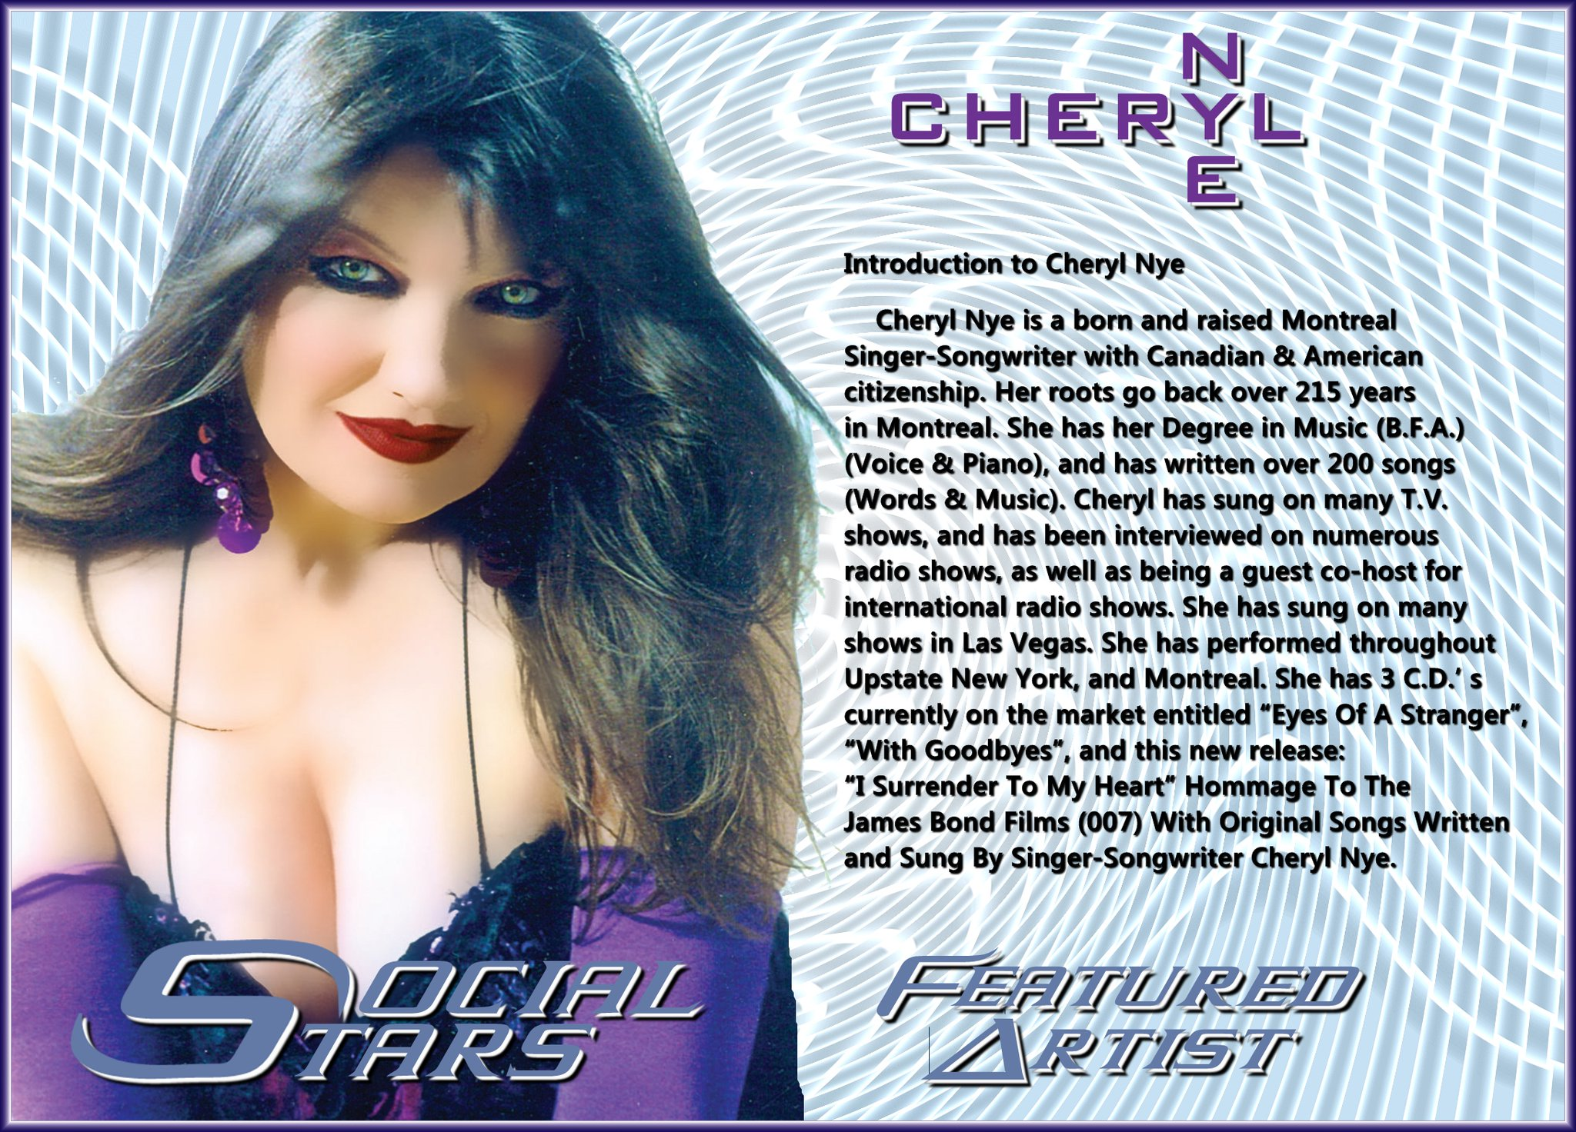

Clouzine Magazine “Discoveries”. (Turkey, 2019).

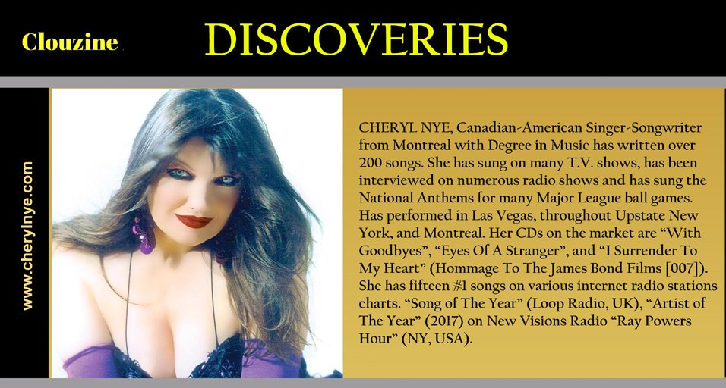

file:///Users/cherylnye007/Desktop/Cheryl%20Nye%20–%20Indie%20Artists%20Magazine.webarchive

Cheryl Nye
“Eyes of a Stranger”
Review by Michael McKenna
Steel Notes Magazine
This Canadian bombshell has just about done it all! She's recorded her music at over 19 different studios from Nashville to Montreal, has appeared in dozens of media events including: news shows, TV shows as an extra, commercials for Gillette and Canadian Air Lines, modeling on the runways of some of the most famous venues, and appearances in Las Vegas and numerous casinos in the US and Canada. Her resume reads like a Who's Who!
But in deference to all those kudos there is one thing that stands out above all the rest, her creativity and expertise in writing, composing and performing over 200 of her countless originals over the past decade. Accolades have poured in from many sources that have ranked her music in the Top 5 on various charts and playlists. She credits her education with a degree in Music (Voice & Piano) as her main influence that drives her to write and compose all her music on a keyboard. She is a One-Woman Powerhouse!
Her latest effort, “Eyes of a Stranger” crosses into many different genres with ease as we can hear the flexibility of Cheryl's many talents. The CD opens with the title track, “Eyes of a Stranger” opens with a full orchestral sound which morphs into a cool rhythmic sounding track. Kevin Grant's Bass guitar work stands out! Her vocals remind me a lot of Natalie Merchant when she sang with 10,000 Maniacs as well as the instrumental backing. “La Manera En Que Necesito Que Me Ames” (Pop Version) has that Southwest/Mexicali/Latino sound especially present in the guitar work and percussion. The ability to perform as a multilingual vocalist just adds to her many talents! “No Stranger To My Heart” features a violin, viola and piano that enhance Cheryl's deep, heartfelt vocal range perfectly.
“Le Destin De Mon Ame” has that Old World flavor as you hear Cheryl's French/Canadian roots and influences come to bear on this ballad. “(The Way I Need To Be)Loved By You” (Pop Version) shows her Nashville sounding backing in this traditional country tear-jerker. “La Manera En Que Necesito Que Me Ames” (Country Version) returns as Spanish-language, country-laced track that is spot on to the English version. “(The Way I Need To Be)Loved By You” (Country Version) adds that little bit of down home flair in this version.
The title track, “Eyes of a Stranger” returns as a dub version with a more intense sounding orchestral mix mated with Wayne Killius's pounding percussion. Mark Dreyer's guitar solo comes screaming at you! I can hear a bit of The Frankfurt Rock Orchestra in this mix! This would do well as a soundtrack for a movie or TV! “Eyes of a Stranger” makes another appearance in a different mold that features Rob Hajacos with his Gypsy Violin which reminds me quite a bit of David Garrett and his technique.
“No Stranger To My Heart/Le Destin De Mon Ame” comes back as an instrumental with way more percussion and strings. I would love to hear a 50 piece orchestra perform this in a concert hall as a medley with one of the classics! “(The Way I Need To Be)Loved By You/La Manera En Que Necesito Que Me Ames” (Pop Version) comes back with a bit of that Mexi/Cali feel to it as an instrumental. “(The Way I Need To Be)Loved By You/La Manera En Que Necesito Que Me Ames”
is also done once again in the instrumental mold this time with a country-laced sound with a bit of a Tex/Mex flair.
The production on this CD is spot on! The musicians backing Cheryl are very talented and have a great feel for what she is projecting to the listener. This is show material throughout and the live show with an orchestra must be fantastic to witness. I give this 2 THUMBS UP!!
— with Cheryl Nye.
